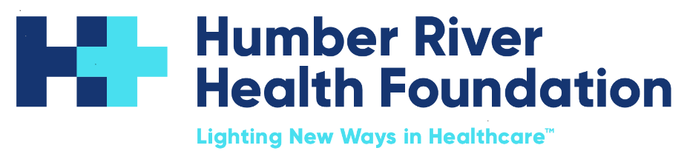

Director Legacy Giving

Humber River Health Foundation | Hybrid (Toronto)

A trusted leadership role at the centre of governance, strategy, and impact.

About the Role & Working Style
Planned giving is a long term and meaningful way for donors to support compassionate patient care for generations. The Director, Legacy Giving will lead, expand and steward the Foundation’s planned giving program, supporting donors considering gifts through wills, insurance policies, securities and other long term philanthropic vehicles.

This role requires a balance of relationship focused donor engagement, technical understanding of planned gift structures and strong internal collaboration. The Director will ensure planned giving is embedded across donor pathways, communications, stewardship strategy and the broader fundraising framework.

In addition, the Director will lead the Foundation’s Planned Giving Committee of ten members, an advisory body consisting of professional advisors, senior volunteers and staff stakeholders who contribute strategic insight, sector awareness and donor pipeline strengthening.

What You’ll Do

Program Strategy and Leadership
- Build and execute a multi year planned giving growth strategy, including revenue forecasts, pipeline development and annual performance targets.
- Develop policies, procedures and donor pathways to strengthen planned giving activity and donor experience.
- Accountable for designing and implementing the end to end legacy donor experience from lead generation through stewardship.
- Ensure planned giving messaging and positioning align with Humber River Health’s strategic priorities and donor impact narratives.
- Prepare regular planned giving reports, dashboards and analytics for the Board and key stakeholders to support strategic decision making and performance tracking.
Leadership of the Planned Giving Committee
- Serve as the main staff lead and coordinator for the Foundation’s Planned Giving Committee, including recruitment, onboarding, meeting agendas, minutes and reporting.
- Engage committee members including legal advisors, wealth planners, senior volunteers, internal leadership and community partners.
- Leverage the Committee as a strategic thought partner for program development, stewardship approaches, campaign alignment and professional advisor outreach.
- Oversee committee supported initiatives including donor outreach, awareness campaigns, estate planning education and prospect identification.
Donor Cultivation and Stewardship
- Manage a personal portfolio of donors and prospects, guiding them through the planned giving process with discretion, respect and thoughtful stewardship.
- Support families, executors and representatives during gift conversations and estate processes.
- Ensure donor recognition and engagement reflect compassion and long term commitment.
- Plan and execute an annual cultivation and stewardship plan with legacy donors and prospects.
Cross Foundation Integration
- Collaborate with Major Gifts, Annual Giving, Donor Relations, Communications and Events to integrate planned giving touchpoints into broader donor engagement and campaign activity, including digital channels and social media.
- Work with Gift Processing, Finance and legal counsel to ensure efficient and compliant estate and planned gift administration.
- Build internal literacy and comfort with planned giving conversations, providing tools, training and support to staff.
- Manage and integrate Raiser’s Edge processes for the planned giving portfolio, ensuring accurate tracking, reporting, moves management and data integrity.
Professional Advisor and Community Relations
- Build strong relationships with professional advisors including estate lawyers, wealth planners, trust officers and accountants.
- Represent Humber River Health Foundation in professional planned giving networks, learning events and sector associations.
- Develop education and outreach initiatives such as seminars, donor guides and advisor briefings.
Estate Administration
- Oversee and support estate management, including documentation review, communication with executors and accurate processing of legacy gifts.
- Ensure CRA compliance, documentation accuracy and full protection of donor intent.
Qualification and Experience
- Eight to ten years of progressive donor facing fundraising experience, including three to five years specifically in planned giving.
- Three or more years of estate administration experience.
- Demonstrated success closing planned gifts and stewarding long term donor relationships.
- Strong working knowledge of planned gift vehicles including wills, RRSP and RRIF designations, securities, insurance policies and tax efficient giving structures.
- Previous committee leadership experience or comfort working with senior volunteers and advisory groups is an asset.
- Proficiency with donor CRM systems, ideally Raiser’s Edge.
- CAGP education, CFP, CFRE or similar designation considered an asset.
- An understanding of equity, diversity, and inclusion principles as they relate to health practices is an asset. Humber River Health values lived and learned experiences in addressing systemic barriers and advancing inclusive practices.
Key Attributes
- Warm communicator who engages in thoughtful, values based donor conversations.
- Collaborative leader who builds trust across internal teams and external partners.
- Approaches planned giving with empathy, professionalism and respect.
- Strategic thinker comfortable with long cultivation cycles and multi year outcomes.
- Demonstrates an entrepreneurial mindset with strong vision, innovation, adaptability, resourcefulness and ability to take initiative.
Additional Information
- Occasional evenings or weekends may be required for donor meetings and Foundation events.

Why Humber River Health Foundation
- Work in close partnership with inspiring executive and volunteer leaders
- Play a meaningful role in advancing healthcare innovation and patient care
- Enjoy a hybrid work environment (3 days in office / 2 days remote)
- Be part of a values-driven organization where trust, professionalism, and impact matter

If you are seeking a role where your expertise, judgment, and leadership are truly valued - and where you can make a meaningful difference every day - we would love to hear from you.

NEXT STEPS:

As part of the hiring process at Humber River Health Foundation, we ask that candidates complete two assessments.

Please set aside 5-10 uninterrupted minutes for completion of the Predictive Index Behavioral Assessment, although you have unlimited time to complete the assessment once it is started. This assessment does not measure intelligence, education or experience. It simply measures work and communication needs. Use this LINK to complete.

Once you have completed the Behavioral Assessment you will receive an email with instructions to complete a second assessment, The Predictive Index Cognitive Assessment. The email will be coming from the address noreply@mailer.predictiveindex.com and may be redirected to your junk mailbox. This is a timed assessment that includes verbal, numerical and abstract reasoning questions. Please set aside 12 uninterrupted minutes for completion.

(NB: The assessment does not measure intelligence, education or experience. It simply measures a person’s capacity to learn, adapt and grasp new concepts.)

