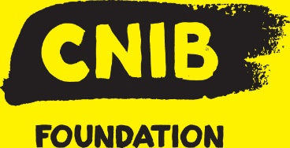

Description
Full-time, Ontario
This is a management level position, directly responsible for the engagement, cultivation and solicitation of donors designated as Planned Giving prospects. This position ensures that established cultivation and solicitation targets are met. The position focuses on the Planned Giving across Canada.

Your impact at CNIB
- Build, plan, manage and implement the Planned Giving Program across the defined territory.
- Identify, cultivate, solicit and close planned gifts from individuals from a prospect and donor portfolio.
- Prepare customized funding proposals, agreements and gift scenarios involving cash, securities, annuities and other planned gift vehicles in order to meet the donor’s personal, estate and financial planning goals.
- Advise prospects, donors, senior volunteers, staff and allied professionals on strategic moves, opportunities and process.

Requirements

Who you are
- Ability to provide strategic solutions to complicated problems in a timely manner.
- Ensure appropriate and timely recognition and stewardship activities for all donors

We want to hear from you if you have:
- BA/BS required
- Must have a working knowledge of CRA guidelines for Charitable Gift receipting for planned gift vehicles as well as a good general understanding of CRA guidelines for charitable gift receipting.
- Must have an understanding of Planned Giving, Planned Giving vehicles and the tax implications of Planned Giving for donors and their estates.
- Previous development experience and/or a background in a non-profit are an asset.
- Planned Giving training (e.g. CAGP Banff course) is an asset
- Experience with fundraising database – Salesforce and Raisers Edge
- Proficient in Microsoft 365
- Personal or professional experience relating to blindness and sight loss is considered an asset
- Personal or professional experience working with assistive technology and/or accessible environments is considered an asset

Benefits
CNIB is committed to creating and fostering an inclusive culture and welcomes applications from diverse candidates, including but not limited to Indigenous peoples, women, candidates with disabilities, and candidates of colour. We strongly encourage applications from applicants with sight loss. Direct lived experience would be a definite asset. We're excited to review your application!
Please note: while we invite applications from all interested and qualified applicants, we are unable to follow-up with every applicant.
Closing date: October 26, 2020

To apply: https://apply.workable.com/cnibfoundation/j/8D6781601D/

Apply for this job

